E-Marketing Homeworks

Meriç Genç

924916012

Marmara University

Management Information Systems / E-Marketing

**Product Life Cycle**

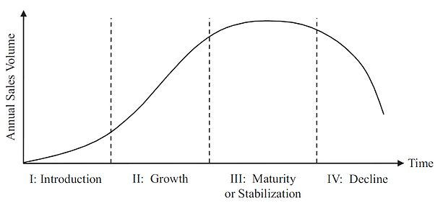

**Intro**

In the introduction stage, the firm seeks to build product awareness and develop a market for the product. The impact on the marketing mix is as follows:

Product branding and quality level is established, and intellectual property protection such as patents and trademarks are obtained.

Pricing may be low penetration pricing to build market share rapidly, or high skim pricing to recover development costs.

Distribution Is selective until consumers show acceptance of the product.

Promotion is aimed at innovators and early adopters. Marketing communications seeks to build product awareness and to educate potential consumers about the product.

There is no competitor, because it is a new product. And in this stage the risk of loss is higher.

**Growth**

In the growth stage, the firm seeks to build brand preference and increase market share.

Many products/services can’t pass this stage. Sales increase on adopted products. It’s bought by the low-income group. The profitability gets the higher level. The market gets bigger. In this stage the real competition starts.

**Maturity**

At maturity, the strong growth in sales diminishes. Competition may appear with similar products. The primary objective at this point is to defend market share while maximizing profit.

All income groups can buy the product.

Competitor firms concentrate on the differences of products.

**Decline**

It’s the last stage of product life cycle. Sales and profitability continues to decrease. Some competitors pull out of the product.

Using the product lifecycle provides to improve the profitable products and discontinue the unprofitable products.

It shows us the progress of the product from presentation to decline stage.

Gartner’s Hype Cycle

The hype cycle is a branded graphical presentation developed and used by American information technology (IT) research and advisory firm Gartner for representing the maturity, adoption and social application of specific technologies. The hype cycle provides a graphical and conceptual presentation of the maturity emerging technologies through five phases.

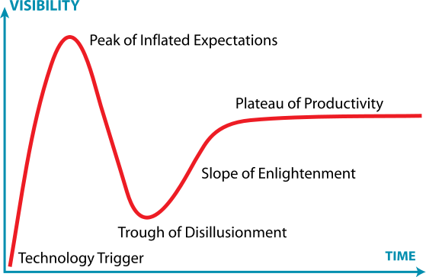

We can example “Autonomous Cars” to Hype Cycle. Although the autonomous cars in the intro stage, almost all the car firms work on the autonomous cars also Apple. But it needs 5-10 years to Gartner.

**Generations**

Each generation has it’s uncase expectations, experiences, generational history, lifestyles, values and demographics that influence their buying behavior.

To get the best feedbacks in marketing, it’s critical to do target audience analysis correctly. The conditions of the period, technology and the dominant ideology affect all the people in the same period. Therefore, every generation has own consume behavior and shopping preference.

The fact of generations also means the people that birth in the same period and affect all the social, economic, cultural, politics in their period.

In basics, there are four different generations in last 100 years. Baby Boomers, Generation X, Generation Y, Generation Z.

**Baby Boomers**

Baby Boomers were born between 1946 and 1964. They approach rational to consumption because they are the generation of war and poverty. They show loyalty to satisfying product with behave accordingly mass marketing. They spend to tourism and health because of their lifetime increased.

**Generation X**

Generation X is the demographic cohort following the Baby Boomers. There are no precise dates for when this cohort starts or ends; demographers and researchers typically use starting birth years ranging from the early-to-mid 1960s and ending birth years ranging from the late 1970s to early 1980s.

They buy the product because of emotional bond to brand not the functions of product. They are the first generation that authenticate their identity with brand.

Generation X acts emotional as far as rational.

**Generation Y (Millennial)**

Millennials are the demographic cohort following Generation X. There are no precise dates for when this cohort starts or ends; demographers and researchers typically use the early 1980s as starting birth years and ending birth years ranging from the mid-1990s to early 2000s.

Generation Y is the first generation to be mentioned by consumption. They are shopaholic with the contribution of internet. They see the consumption like an entertaining game.

**Generation Z**

Generation Z is the demographic cohort after the Millennials. There are no precise dates for when the Gen Z cohort starts or ends; demographers and researchers typically use starting birth years that range from the mid-1990s to early 2000s, and as yet there is little consensus about ending birth years.

While we don’t know much about Gen Z yet. We know a lot about the environment they are growing up in. This highly diverse environment will make the grade schools of the next generation the most diverse ever. Higher levels of technology will make significant inroads in academics allowing for customized instruction, data mining of student histories to enable pinpoint diagnostics and remediation or accelerated achievement opportunities.

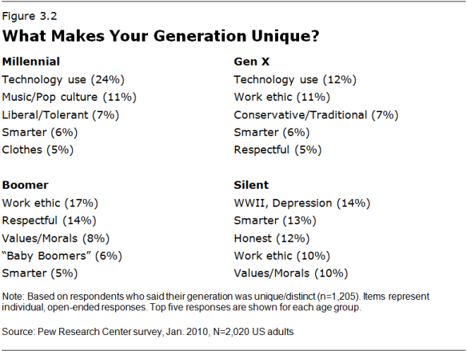

**Augmented Reality Vs Virtual Reality**

There are lot of techniques used to impress consumer. The firms compete to answer to consumer’s necessities and become a part of market. Augmented Reality and Virtual Reality are two of this techniques.

Augmented reality is the blending of virtual reality and real life, as developers can create images within applications that blend in with contents in the real world. With AR, users are able to interact with virtual contents in the real world, and are able to distinguish between the two.

Virtual reality is all about the creation of a virtual world that users can interact with. This virtual world should be designed in such a way that users would find it difficult to tell the difference from what is real and what is not. Furthermore, VR is usually achieved by the wearing of a VR helmet or goggles similar to the Oculus Rift.

Both virtual reality and augmented reality are similar in the goal of immersing the user, though both systems to this in different ways. With AR, users continue to be in touch with the real world while interacting with virtual objects around them. With VR, the user is isolated from the real world while immersed in a world that is completely fabricated. As it stands, VR might work better for video games and social networking in a virtual environment, such as Second Life, or even PlayStation Home.

**Cross Selling**

Cross-selling is a sales technique used to get a customer to spend more by purchasing a product that’s related to what’s being bought already. Doing for increase sales of subsidiary products.

Amazon reportedly attributes as much as 35 percent of its sales to cross-selling through its “customers who bought this item also bought” and “frequently bought together” options on every product page. That approach allows a retailer to prompt a shopper to buy a compatible – or necessary – product.

Suggesting a memory car to digital camera buyer. A shaving foam to razor blade buyer. These are some kind of examples to cross selling.

Cross-selling in the ecommerce environment involves identifying related products and creating appropriate offers while in-person cross-selling could require training in effective approaches. In both cases, though, the goal is to make more money for the company while creating a satisfied customer.

**Viral Marketing**

Viral marketing is a buzzword for promotional messages that spread through social networks. Viral marketing campaigns hinge on finding a catchy medium for a message and then propagating it through different online channels including blogs, microblogs, posts, crowdsourcing and so on. The actual message may be in the form of an advertorial, but is more likely to come in the form of a branded game, video clip, image or other format that can be branded. Generally speaking, the goal of a viral marketing campaign is to raise brand awareness - or mindshare - rather than convert clicks into sales of a specific product.

It spreads easily from small to large audience. For making viral marketing, need a message that is attractive or advantage provider.

**Advantages of Viral Marketing**

Low cost: What characterizes viral campaigns is that the users do a significant part of the work for us, which drastically cuts down the costs of dispersion: it becomes unnecessary to buy advertising or space on the media.

Potential of great reach: A viral video on the Internet has the ability to reach a huge international audience without us having to invest money or make any extra effort. Due to this, a small company or even a private individual can go extremely far.

It is not invasive: In viral marketing, the decision to participate and share always comes from the user, and so it never comes across as invasive. Like this, the perception of the brand and the interaction are significantly better, compared to more classical forms of advertising.

It helps build up your brand: If we really hit the bull’s-eye in terms of creativity, we are creating content so incredible that users themselves decide to share it and, hence create a personal connection with your brand. It is without a doubt an extremely powerful tool when it comes to branding and awareness.

For example, the unboxing videos are viral marketing. Because it introduces the product and it’s almost free to record and share. And the video easily reaches the audience.